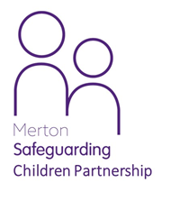 Are you staying with someone who is not a close relative?



**For more information**

Contact Merton Child and Family Hub.

**By telephone: 020 8545 4226**

**By email:** [**candfhub@merton.gov.uk**](mailto:candfhub@merton.gov.uk)

**Are you are under 16 (or under 18 if you are disabled) and staying with someone who is not your Mum, Dad, Nan, Grandad, Aunt, Uncle, brother, sister or step-parent?**

**It could be a neighbour, family friend**

**or parent of one of your friends**

**Have you been staying with them for more than 28 days in total?**



**Talking with Social Workers**

When you begin staying with your private

carer Children’s Social Care will send a

social worker to talk to you privately to make sure you arehappy and safe.

If you are not happy, tell them and they will try

and make things better for you.

**What happens next?**

The person you are staying with is called your **private foster carer**.

Somebody has to let Children’s Social Care

know that you are not staying at home.

This could be your parents, private foster carer, school, or even your doctor