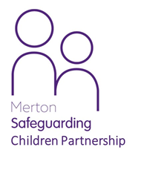
Are you looking after someone else’s child?
Is the child you are looking after someone who isn’t a close relative?
If you are doing this for 28 days or more, this is a private fostering arrangement
WHAT is private fostering?

If the child is under 16 years of age, (or under 18 years and have a disability) is staying with someone other than a close relative for more than 28 days in
total, it is a private fostering arrangement.

A close relative is:
• a parent
• a biological aunt or uncle
• a grand parent
• a sibling
• a step parent by marriage or civil partnership
WHO do I need to tell?

You must tell Children’s Social Care if you have, or are planning to have, a child living with you who is not your close relative for 28 days or more

You can contact Merton Child and Family Hub.

By telephone: 020 8545 4226
By email: candfhub@merton.gov.uk

WHY do I need to let social care know?

This is to make sure young people in Private Fostering arrangements are safe by speaking to them and their parents and carers. Private foster carers can access support through the Family Information Service. Social Workers will make regular visits to see how the child is getting on
Children are privately fostered for a number of reasons:

• Separation, divorce or arguments in the child’s family

• the young person is the partner of one of your own children

• For health, cultural or educational reasons

